Faculty of Computer Science & Engineering

Assignment Number – 3

Name : Prajyot Chandrashekhar Bhamare. F.Y. B.Tech. Division 2 (B1)

Roll no.: 102032 PRN no.: 1032190054

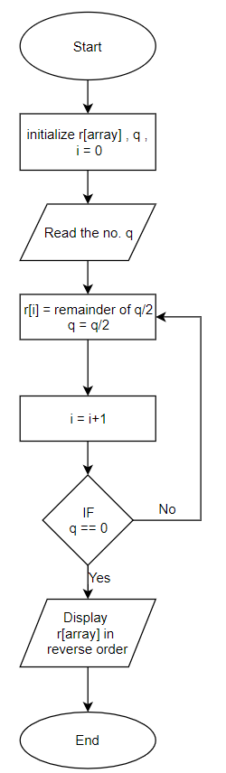Algorithm

Step 1: Start.

Step 2: Initialize array a, q, i = 0.

Step 3: Read the input number from the user q.

Step 4: Store value of remainder of q/2 in the array a at ith place.

Step 5: Store value of q/2 in q.

Step 6: Increment counter i by 1.

Step 7: If q not = 0 goto step 4.

Step 8: Display the array a in reverse order to the user as the binary output.

Step 9: End.